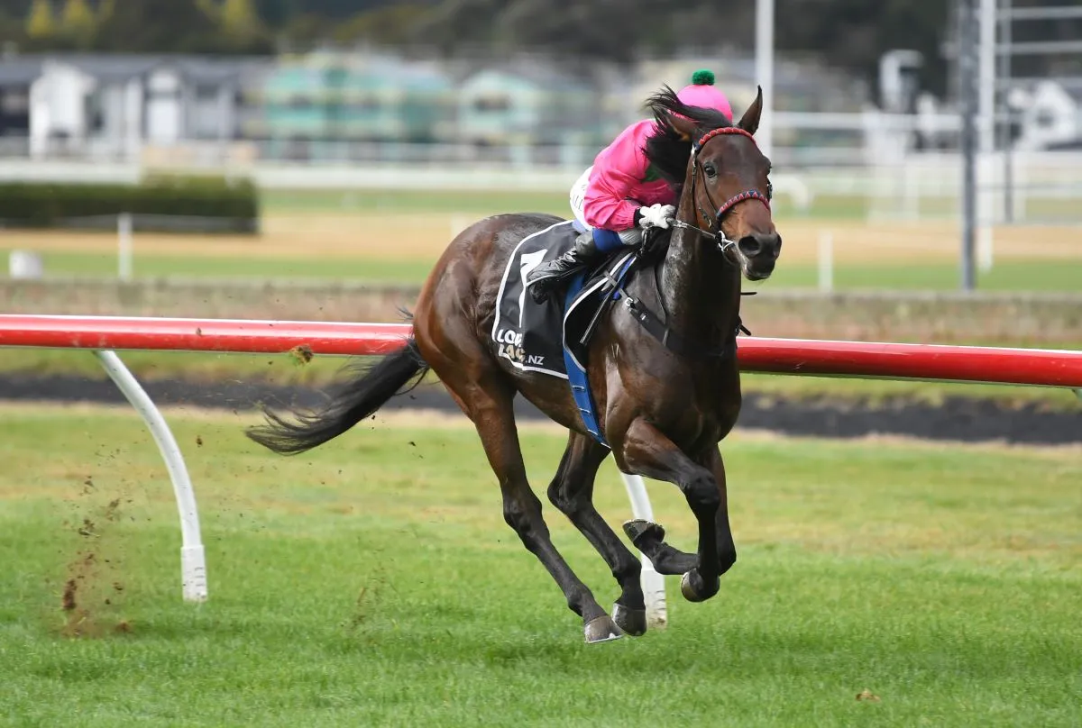
Product Disclosure Statement

First Gear Syndicate
10% Leasehold Stake in First Gear (NZ)
Evolution Stables – NZTR Authorised Syndicator
Date: 08 August 2025
Evolution Stables
alex@evolutionstables.nz | +64 21 0828 0901
evolutionstables.co.nz

A New Way to Own
Evolution Stables is a New Zealand–based, NZTR‑authorised syndicator, and the first to offer tokenised racehorse syndication fully aligned with both NZTR regulations and global virtual asset frameworks.
We partner with leading owners and trainers to lease premium bloodstock, then make those opportunities available in fractional, fixed‑term digital shares. This lowers the cost of entry and simplifies ownership, giving more people the chance to experience the sport from the inside.
To deliver this securely and at scale, we work with Tokinvest, a licensed and regulated platform (Dubai VARA‑approved) that manages investor onboarding, compliance, and secure digital issuance of your syndicate tokens.
Our approach blends the tradition, passion, and community of racing with modern technology and transparent processes—helping to build the next generation of owners.

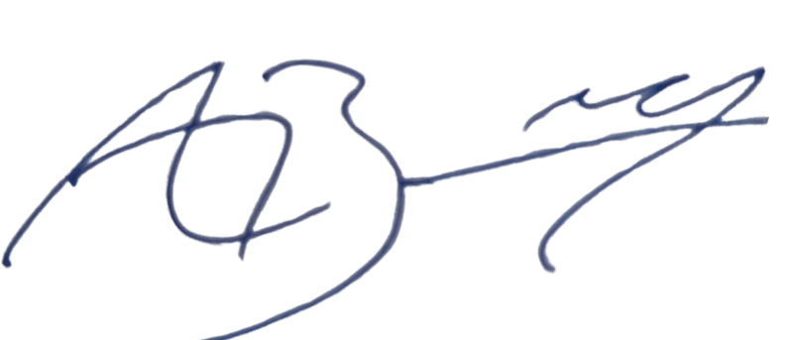

Alex Baddeley
Founder, Evolution Stables

Key Information Summary

What is this?
This Product Disclosure Statement outlines a 12-month leasehold interest in First Gear, a New Zealand thoroughbred. Evolution Stables has secured a 10% leasehold stake in the horse and is making fractional participation available to investors through its digital-syndication model.
Who is this for?
Individuals seeking exposure to racehorse ownership in a simplified, digital format—no prior experience required.
How does it work?
You lease a share of our 10% stake in First Gear. Your one-time fee covers all costs for the term. You receive 80% of any revenue generated from racing, sponsorship, or commercial activity, proportional to your share.

Structure
The 10% leasehold interest in First Gear is:
- Split into 20 digital tokens (each representing 0.5%)
- Fixed for the term 1 July 2025 to 30 June 2026
- Fully managed by Evolution Stables
- Digitally issued and administered via Tokinvest (regulated by VARA, Dubai)

Returns
Returns are variable, based on race performance and commercial revenue. There are no guarantees, and you may not recover your original investment.

Fees
$480 per 1.0% token (fixed, covers all costs)
- Fees: 7% Tokinvest, 5% Evolution Stables (deducted from upfront payment)

Race Schedule Expectation
First Gear has progressed well in his training following a short spell. He is now ready to resume his racing career in the near future. Syndicate members can expect regular updates and potential race entries within the first few weeks of the lease.

Risks
The horse may underperform, suffer injury, or be retired early.
Early termination may result in a pro-rata refund.
Limited liquidity—resale may not be immediate or available.
You could lose the full amount of your investment. (See Section 12.)

How to Invest
Applications are made directly through Evolution Stables. Once your allocation is confirmed, it will be securely recorded and administered via our partner Tokinvest, a licensed and regulated digital issuance platform. Identity verification is required under AML/CFT laws. (See Section 19 – Investment Details.)

Manager
Evolution Stables Ltd (NZBN: 9429050177875) is an authorised NZTR syndicator specialising in digital-syndication of leasehold interests in New Zealand thoroughbreds. (See Section 1.)

Contents
- About Evolution Stables
- About the Horse – First Gear
- Upfront Costs and Expenses
- Revenue Streams
- Ongoing Costs and Expenses
- Minimum Amount
- What Taxes Will You Pay?
- Insurance Information
- Valuation Reports
- Veterinary Report
- Material Interests and Commissions
- Risk Disclosure
- Responsible Investment
- Legal Structure and Oversight
- Termination & Forfeiture
- Transfer of Interests
- Records and Administration
- How to Complain
- Investment Details
- Investor Declaration
- Promoter Declaration
Appendix

1. About Evolution Stables
Evolution Stables is a licensed NZTR-authorised syndicator that’s reshaping how people experience racehorse ownership. We believe that owning a stake in a racehorse should be exciting, flexible, and accessible—not bogged down by outdated structures or high barriers to entry.
Our approach is built around the idea of digital-syndication. This means fractional ownership, simple onboarding, and clear timeframes—all enabled by digital infrastructure. Our leases are short-term, fixed-cost, and designed for modern investors who want real participation with minimal complexity.
Behind Evolution Stables is a team with experience across financial markets, digital assets, and the racing industry. Our platform is designed to open the gate for a new generation of owners, while still honouring the traditions that make racing special.

We work closely with:
- NZTR to ensure full compliance with New Zealand’s racing and syndication rules.
- Tokinvest, our digital issuance partner, licensed under Dubai’s VARA framework, providing global-grade compliance and token management.
- Leading studs, trainers, and bloodstock agents, giving our syndicate members access to high-potential horses and real industry insight.

Why it matters
Ownership is declining across racing’s traditional base. By introducing flexible, secure, and transparent ways to participate, we’re building a new path forward—one where racehorse ownership is something you can experience, enjoy, and share.
This is a fully managed syndicate—professionally operated on your behalf. Token holders do not carry governance rights, but are welcomed as valued participants in the journey. We handle the racing, compliance, and communications so you can enjoy the experience, not manage it.

2. About the Horse – First Gear
First Gear (NZ) is a 3-year-old gelding by Derryn (AUS) out of A’Guin Ace (NZ), a daughter of the prolific stallion O’Reilly. Bred in New Zealand, First Gear combines sprinting bloodlines with one of the country’s most respected broodmare sires, offering a compelling mix of speed and durability.
First Gear is currently trained by Stephen Gray at Copper Belt Lodge in the Manawatu. Known for his patient development style and success across both New Zealand and Singapore, Stephen brings a wealth of experience and professionalism to First Gear’s preparation.
The 10% lease secured by Evolution Stables gives syndicate members a rare opportunity to follow a well-bred young horse through a full racing season—from training updates to race day.

Key Details
- Name: First Gear (NZ)
- Foaling Date: 2 October 2021
- Colour: Bay
- Sex: Gelding
- Height: 16.2 hands
- Sire: Derryn (AUS)
- Dam: A’Guin Ace (NZ)
- Trainer: Stephen Gray
- Training Base: Copper Belt Lodge, 643 Mount Stewart Halcombe Road, Feilding, New Zealand
- Life Number: NZ00428364
- Microchip Number: 985125000126713
- Lease Duration: 12 months (1 July 2025 - 30 June 2026)
- Stake: 10% leasehold interest held by Evolution Stables
- Listing: 20 digital tokens (0.5% each)
- Record: 5 starts, 1 win, 2 seconds

Racing Outlook:
First Gear has recently returned to training after being spelled following his last racing cycle. He is expected to resume racing shortly after the lease term begins. While race entries depend on fitness, nominations, and trainer discretion, syndicate members can expect regular updates and potential race day appearances within the first 4–8 weeks of the lease commencement.
Whether you’re drawn to the bloodlines, the trainer, or the horse’s early results, First Gear offers a high-quality, short-term ownership experience—with a clear timeframe and strong upside.

3. Upfront Costs and Expenses
The First Gear Syndicate is structured as a simple, fixed-cost lease, with no ongoing costs for the term of the lease. You pay one upfront amount to participate—that’s it.
Total Lease Cost: $480 per 1.0% token
This cost includes:
- Training and care
- Syndicate management and reporting
- NZTR registration and compliance
- Tokinvest platform and digital issuance/administration
- All other routine costs associated with the horse for the full term

4. Revenue Streams
Your share in the First Gear Syndicate gives you access to potential earnings generated by the horse during the lease period. While returns are variable and not guaranteed, your investment entitles you to a portion of all eligible income the horse may produce.
Revenue sources may include:
- Prizemoney from official race results
- Sponsorship or endorsement deals
- Digital media rights or content-related income
- Commercial opportunities such as naming rights, merchandising, or syndicate-specific promotions

How Distributions Work
All revenue generated by First Gear during the lease period is paid by the horse’s owner to Evolution Stables as the leaseholder. Under the lease arrangement, 80% of gross revenue is allocated to the syndicate (token holders), with the remaining 20% retained by the owner.
Distributions to token holders are made pro rata according to each participant's shareholding.
All distributions are made in NZD and processed via the Tokinvest platform, which may deduct applicable transaction or platform fees (see Appendix A for details).

5. Ongoing Costs and Expenses

There are no ongoing costs.
Your upfront lease fee is all-inclusive. Evolution Stables manages all expenses related to the horse throughout the lease period. You will not be asked to contribute additional funds, regardless of race schedule, training demands, or location.
Any deductions from potential revenue (e.g. admin fees, platform costs) are applied only if income is generated—and are outlined in full in Section 4 and Appendix A.

6. Minimum Amount
The minimum investment is 0.5%, representing one digital token in the 10% leasehold stake secured by Evolution Stables.
Each 0.5% token costs $240 NZD and includes:
- Full access to updates and reporting
- Eligibility for revenue distributions
- Platform-verified token issuance through Tokinvest
Investors may purchase multiple tokens, subject to availability. All shareholdings are fractional, and returns are proportional to your ownership percentage.

7. What Taxes Will You Pay?
Revenue earned from your participation in the First Gear Syndicate may be subject to tax, depending on your individual circumstances and jurisdiction.
This may include:
- Income Tax on prizemoney or other distributions received
- Capital Gains Tax (if applicable in your jurisdiction) on the resale of digital tokens
- GST/VAT implications depending on your location and whether you’re registered for tax purposes
Important Disclaimer:
Evolution Stables does not provide tax advice. We strongly recommend that all investors seek independent professional advice regarding their personal tax obligations, including any tax that may apply to prizemoney or other revenue distributions.

8. Insurance Information
The horse is insured by the owner for mortality and other risks during the lease term. Leaseholders are not beneficiaries under the policy.
If the horse dies or is permanently retired during the lease period, the lease ends immediately. In this case, leaseholders will receive a pro-rata refund of the unused lease fee based on the remaining lease term.

9. Valuation Reports
As this is a lease-only syndicate, no formal valuation is required or provided. NZTR does not require valuations for lease arrangements, as no equity ownership in the horse is being transferred.

10. Veterinary Report
First Gear is currently in sound racing condition and has been actively training with no reported issues. A recent veterinary assessment confirms his suitability for continued racing and leasing purposes.

11. Material Interests and Commissions
Evolution Stables receives a portion of any revenue generated during the lease period as part of its management structure. This is outlined transparently in Section 4 (Revenue Streams) and forms part of our standard model to cover operating costs and ensure long-term platform sustainability.
No undisclosed commissions, fees, or referral arrangements have been entered into between Evolution Stables and any third parties in connection with this syndicate.
If any future material interests arise, they will be disclosed promptly and transparently to all lease participants.

12. Risk Disclosure
Participation in the Evolution Stables – First Gear Syndicate involves inherent risks. While Evolution Stables has structured this offering to provide a clear and limited exposure through a fixed-term lease, you should carefully consider the following:
- Performance Risk: First Gear may not perform to expectations on the track. Poor race results can reduce or eliminate potential revenue.
- Injury or Retirement: The horse could suffer injury, illness, or be retired early. In such cases, the lease may terminate early, and you may receive a pro-rata refund of the unused portion of your lease fee—but no compensation beyond that.
- Regulatory Risk: NZTR has the authority to suspend or deregister a horse or syndicate. The lease will automatically terminate if NZTR accepts a deregistration (Form SR24) for First Gear.
- Forfeiture Risk: Leaseholders may forfeit their rights if they provide false or misleading information, fail AML/CFT requirements, or are declared ineligible under the Rules of Racing (including NZTR Rule 411(b)). In such cases, participation may be cancelled without refund.
- No Ownership Rights: Leaseholders have no legal ownership of the horse and no entitlement to insurance proceeds or decisions regarding the horse’s future.
- No Guaranteed Returns: Revenue is variable and cannot be predicted. You may not receive any distributions and may not recover your original investment.
- Liquidity Limitations: Resale of any lease interest is only permitted in accordance with Tokinvest’s rules.
You should not invest unless you can afford to lose the full amount of your lease fee. We recommend you seek independent financial or legal advice before participating.

13. Responsible Investment
At Evolution Stables, we believe in a responsible approach to racehorse syndication—one that respects the animal, the investor, and the integrity of the sport.
We adhere to the following principles:
- Welfare First: All horses syndicated through Evolution Stables are placed with reputable trainers and cared for in accordance with New Zealand Thoroughbred Racing’s welfare guidelines. First Gear is currently trained at Copper Belt Lodge under the experienced care of Stephen Gray, who is known for prioritising equine welfare and responsible conditioning.
- Transparency and Communication: Investors receive regular updates throughout the lease period, including race nominations, results, and veterinary information where applicable. We aim to create a transparent, informed ownership experience.
- Integrity and Compliance: We operate in full compliance with NZTR regulations and global virtual asset frameworks. All lease arrangements are documented, approved, and lodged in accordance with the relevant standards.
- Sustainability of the Sport: We support initiatives that broaden access, increase transparency, and make racehorse ownership more inclusive and financially sustainable.
By participating in the First Gear Syndicate, you’re helping create a more open, accountable, and engaging future for thoroughbred racing.

14. Legal Structure and Oversight
The Evolution Stables – First Gear Syndicate is governed by the attached Syndicate Agreement, which outlines the structure, responsibilities, and rights of all participants. Key provisions include:
- Syndicate Purpose: Participating in the racing career of First Gear as a recreational pursuit.
- Manager’s Role: Oversight of training updates, NZTR registration and compliance, and the management of any revenue distributions.
- Operational Procedures: Processes for handling disputes, share transfers, and defaults.
- Regulatory Oversight: NZTR’s authority to remove or replace the manager (see Clause 18.4).

Authorised Representative
The Syndicate Manager (Evolution Stables Ltd) is the authorised representative of the Evolution Stables – First Gear Syndicate for the purposes of registration and compliance with New Zealand Thoroughbred Racing Inc. (“NZTR”). The Syndicate Manager is empowered to sign and execute, on behalf of the Syndicate and its leaseholders, any form or document required by NZTR in relation to the Syndicate, its horses, or the interests of its leaseholders. This authority is limited to regulatory and administrative matters necessary to manage the Syndicate in accordance with the Rules of Racing, the Syndicate Agreement, and this Product Disclosure Statement.
Participants are strongly encouraged to read the Syndicate Agreement in full and seek independent legal advice before committing. The syndicate is also subject to the Rules of Racing, administered by NZTR.
This Syndicate Agreement and the terms of this Product Disclosure Statement are governed by the laws of New Zealand. All participants agree to submit to the non-exclusive jurisdiction of the New Zealand courts in relation to any disputes arising under or in connection with this syndicate.

15. Termination & Forfeiture
The Syndicate and each leaseholder’s participation will end on 30 June 2026.
Early Termination:
- The lease will terminate if First Gear is retired, deregistered, or otherwise made ineligible to race under the Rules of Racing.
- A lease will also be deemed terminated if the registered owner or Syndicate Manager submits, and NZTR accepts, Form SR24 deregistering the horse.
- NZTR may, at its discretion, suspend or cancel the Syndicate in accordance with the Rules of Racing.
Forfeiture:
Leaseholders may forfeit their rights in the Syndicate if they:
- Provide false or misleading information during the application process; or
- Are declared ineligible to participate under the Rules of Racing, including NZTR Rule 411(b).
In the event of forfeiture, the Syndicate Manager may cancel the leaseholder’s participation in the Syndicate in accordance with NZTR requirements.

16. Transfer of Interests
Interests in the Evolution Stables – First Gear Syndicate may only be transferred in accordance with:
- The Rules of Racing administered by NZTR, including the requirement that all lease interests are formally registered; and
- The rules of Tokinvest, which govern how lease interests may be transferred between participants on its platform.
All transfers must be recorded by the Syndicate Manager and registered with NZTR. No transfer will be valid until it has been approved and reflected in NZTR’s records.

17. Records and Administration
The Syndicate Manager will maintain appropriate records of the Evolution Stables – First Gear Syndicate in accordance with the Rules of Racing and NZTR’s Syndication Code of Practice.
All lease payments are fixed and payable in advance. As such, there are no ongoing calls for funds or monthly contributions. The Syndicate Manager will ensure that all required documentation, lease registrations, and regulatory filings are completed and retained.

18. How to Complain
If you have a concern or complaint in relation to the Evolution Stables – First Gear Syndicate, the following steps are available:
- Contact Evolution Stables
Email: alex@evolutionstables.co.nz | Phone: +64 21 0828 0901
- Escalate to NZTR
If your concern is not resolved, you may escalate the issue to New Zealand Thoroughbred Racing (NZTR).
Contact: Colin Hall | Email: syndication@nzracing.co.nz
- Request Mediation
If required, you may request independent mediation through an NZTR-approved mediator. There are no fees for lodging a complaint or accessing mediation services.
All complaints are handled in accordance with NZTR’s protocols for authorised syndicates. Decisions made under the Rules of Racing are final and binding on all participants.

19. Investment Details
I hereby apply for the following interest in the First Gear Syndicate:
- Number of tokens applied for: ______ (minimum 1 token = 0.5%)
- Total % interest: ______ %
- Application Amount (NZD): $ ____________

20. Investor Declaration
By signing this Application Form, on the _________________, I acknowledge and agree that:
- I have received, read, and understood the Product Disclosure Statement (PDS) and the Syndicate Agreement for the First Gear Syndicate.
- I agree to be bound by the terms of the Syndicate Agreement, the PDS, and the Rules of Racing administered by NZTR.
- I understand that my participation is strictly as a leaseholder and confers no ownership rights in the horse.
- I understand the risks set out in the PDS, including that I may not recover my original investment.
- I consent to my details being provided to NZTR and Tokinvest for compliance with AML/CFT, registration, and regulatory purposes.

Name: _____________

Signed: _____________ Date: _____________

21. Promoter Declaration
I, Alex Baddeley, as the promoter of this syndicate, declare that the information provided in this Product Disclosure Statement is, to the best of my knowledge, true and correct, and that I am not aware of any information that would make this statement misleading in any material respect.

Signed: _____________ Date: _____________
Alex Baddeley
Director, Evolution Stables Ltd
8 Huia Street, Auckland, New Zealand
alex@evolutionstables.nz | +64 21 0828 0901

Appendix
Appendix A – Platform Fees and Revenue Types
Appendix B – Potential Revenue Streams
Appendix C – Veterinary Report (First Gear)

Appendix A – Platform Fees and Revenue Types
Tokinvest Platform Fees:
- As part of the upfront, all-inclusive lease fee, 7% is allocated to Tokinvest to cover platform, transaction, and token issuance services.
Evolution Stables Fees:
- A 5% fee is allocated to Evolution Stables from the upfront lease payment to cover the costs of syndicate management and ongoing administration.

Appendix B – Potential Revenue Streams
Token holders receive a revenue share (for First Gear, 80%) of all revenue generated by the referenced horse during the lease period, proportional to their leased stake. The following categories outline typical potential revenue sources:
Category | Description
Race Winnings | Standard prizemoney from official race results, including base pools/bonuses
Sponsorship & Endorsements | Income from brand partnerships involving the horse, silks, or syndicate representation
Media & Naming Rights | Earnings from appearances, naming rights, or features in documentaries
Digital Asset Income | Royalties or direct proceeds from NFTs or other digital memorabilia
Appearance Fees | Revenue from parades, exhibitions, or promotional appearances
Merchandising & Hospitality | Proceeds from branded merchandise and curated race-day experiences
Data Licensing | Earnings from licensing biometric or performance data to third parties
Exit or Breeding Proceeds | If the horse is sold or earns breeding revenue during the lease, token holders may receive a share. Subject to standard buyout clause: 3x the remaining lease value.
Other Commercial Revenue | Any other verifiable income directly attributable to the horse during the lease.
Appendix C – Veterinary Report (First Gear)
This section includes the most recent veterinary assessment of First Gear (NZ00428364), conducted for the purpose of this syndication. The report confirms that First Gear is in sound racing condition and is suitable for continued training and racing under the lease terms.

